<https://youtu.be/dQZ64hZoqi0>

Install dot net framework 4.5

SQL server 2016 doesn’t support with windows 7. Install 2014

Keep instance name as SQL express, we will use the same name while configuring blue prism

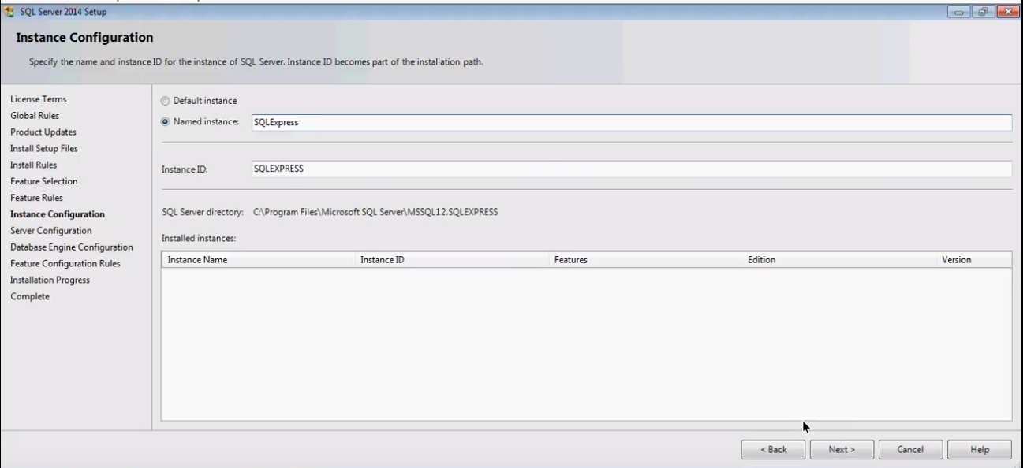

Set both to automatic

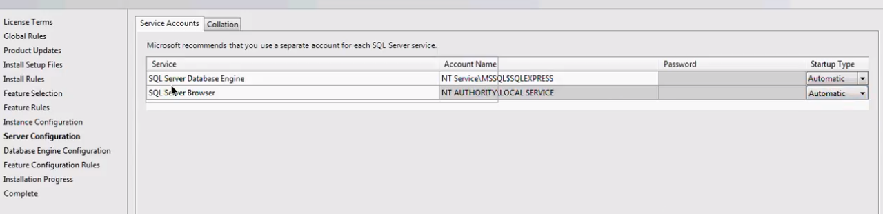

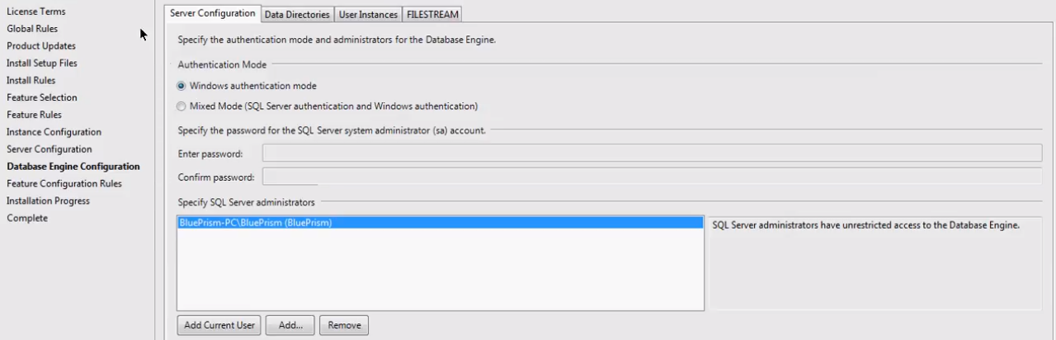

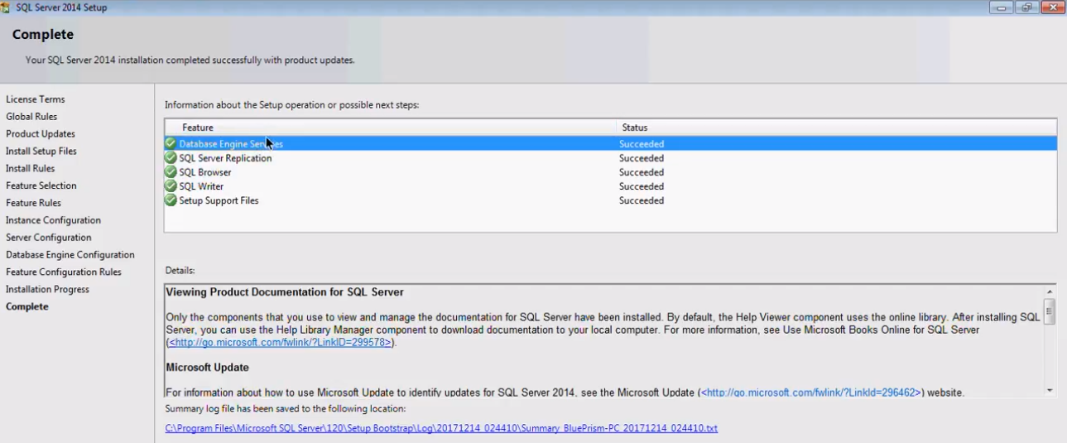

Most imp installation are the Database Engine Services and SQL Browser

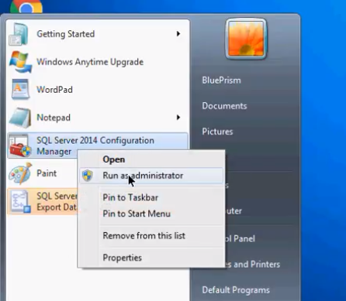

Make sure both below options are set to automatic

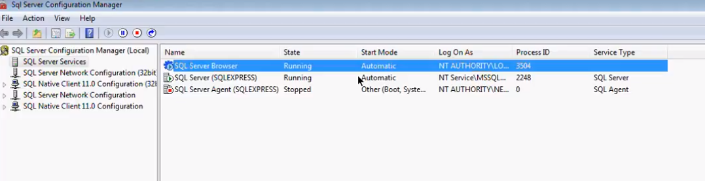

If not go to services.msc

For both -- > Properties > Logon > Logon as : > Built in account > Local System

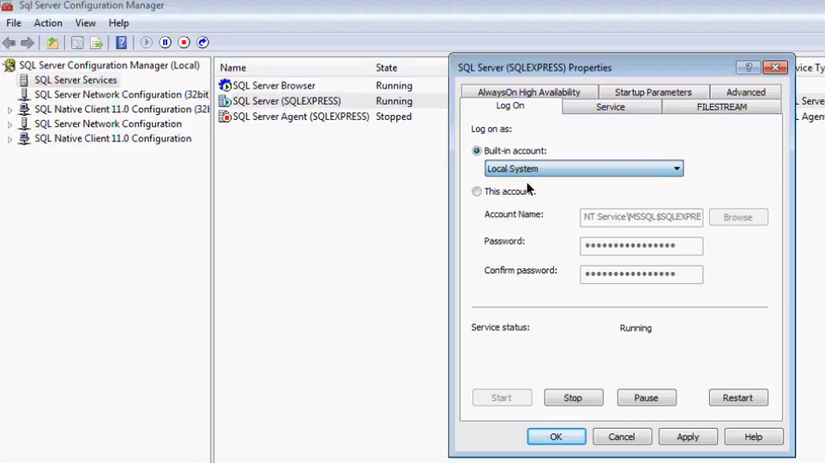

Install Java 8

Setting up Blueprism

After installing and opening

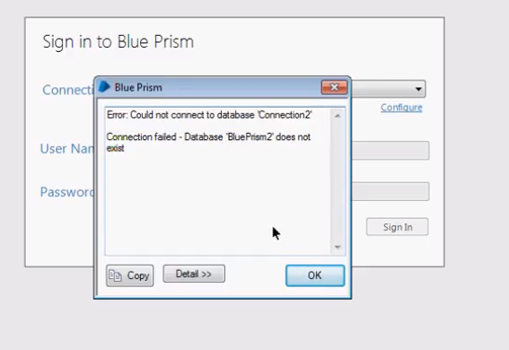

Click on configure

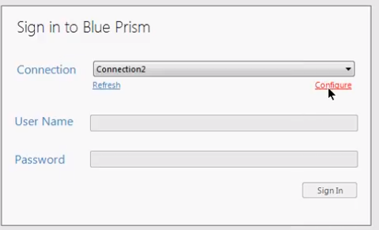

Provide any connection name

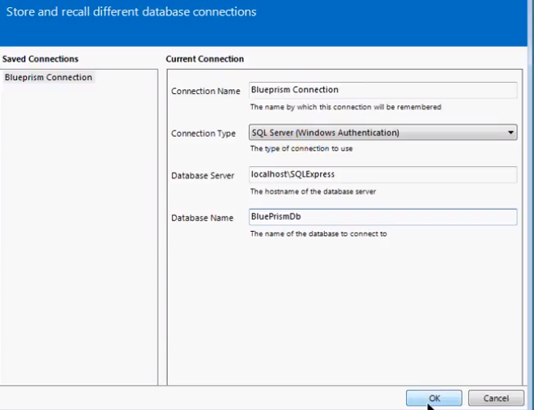

Before Clicking OK, it will give an error , ignore as we need to create a database named BluePrismdb

Click on File > Create Database

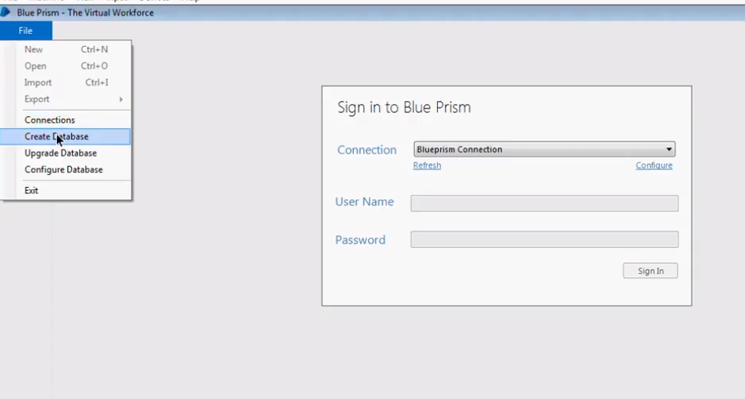

Default values will get populated based on the connection details. Don’t change anything and click OK

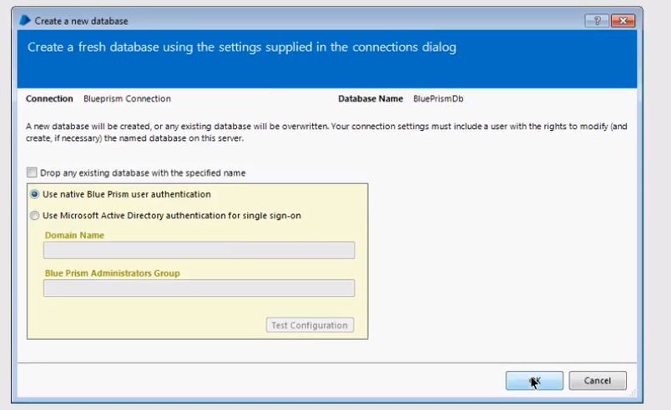

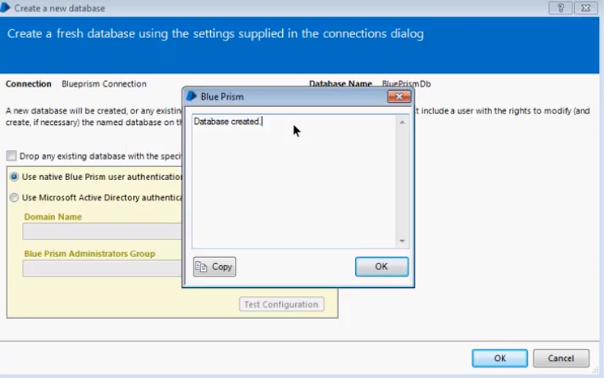

Default username and password is admin for signing in to blueprism

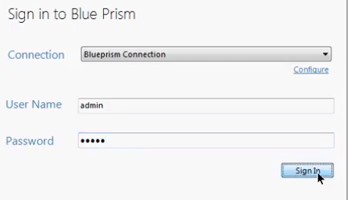

It will then ask you to reset password

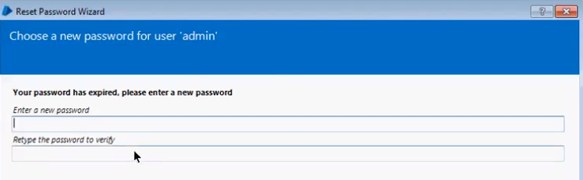

Go to system tab >License > Install New License and upload license (make sure we backdate system)

